[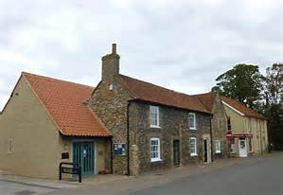](https://www.bing.com/images/search?q=mildenhall+museum&view=detailv2&&id=170C3AD6A717518A0AFCDEC08A3086D81C7E2320&selectedIndex=1&ccid=BNv+WxQo&simid=608013288109835379&thid=OIP.M04dbfe5b14281f3686338dcd3a9e4c70o0)**The Mildenhall Post**

Mildenhall Museum Society Newsletter

NOVEMBER 2024

Editor: kay.finnis@yahoo.co.uk

**News from the trustees.**

It has been a very busy summer. In July to coincide with the Olympic games we had a temporary display related to some of the Olympic sports that are available locally. We also had a children’s summer holiday activity. Thanks to Trustee Kathryn Thompson for organising both.

The Olympic display was followed by one related to the 90th anniversary of the Great Air Race from Mildenhall to Melbourne Australia. This will remain until we close in December. Our thanks to two local enthusiasts for lending us their memorabilia. Kathryn has, yet again, devised a children’s activity this time connected to the race.

The weekend of the 18th, 19th  and 20th October was the highlight of the celebrations. The Mildenhall Flower Club had a flower festival in Mildenhall Methodist Church in which the seven compulsory checkpoints of the race were the inspiration for their amazing arrangements. On the evening of the 18th Anne Hughes and Carol Cooper gave a talk about the race in the church. On the 19th the Council put on a swingband concert in the Jubilee Centre. The museum opened extra hours to match the festival and we were very busy.

Earlier in the year we published a book by Brian Soper entitled **Memories of the Great Air Race 1934** [price £5] which has sold very well and has gone to a second edition.

A lady called Maureen Bloom who lived in Mildenhall for many years wrote a book about her memories of Mildenhall in the 1950s. The museum provided her with photos to illustrate it. She very generously gave us 50 to sell and they were so successful she gave us another 50. She requested that we sell them for £7 each We are very grateful for her generosity.

We have been sorry to learn of the death of two of our members. Alan Benton was speaker finder for the society for many years and gave guided tours of the Old Cemetery and Kingsway.

Sylvia Pulzer was a stalwart volunteer know for her helpfulness and cheery way. She was nicknamed St Sylvia by one of our other volunteers!

Stephanie Palmer

Mildenhall museum society

Dear Member.

November saw the last of the Thursday evening talks for 2024. Sarah Doig gave a fascinating glimpse into the early customs and lore of Christmas, bringing us up to date with the festival we know today.

David Palmer has done another great job in securing a wide range of speakers for us and seems to have already managed to fill the calendar for 2025. We are most grateful for his efforts here.

Talking of efforts, please remember that the AGM will be held in the Museum on the second Thursday in January, rather than the first which is our normal meeting day. This is to allow any New Year’s celebrations to be recovered from and perhaps for visiting family and friends to have gone home. 2pm is the start time and we have Kevin Boardman back with us to give one of his interesting talks.

I have been asked once or twice during the year about Society functions and fund raisers. I know I mention this every year but, without new ideas of what might appeal to you our members, it becomes a problem for the committee, which is already diminished in numbers. New volunteers are few and far between and the four or five of us who are left can’t do much more than we are already doing. Any ideas would be gratefully received even if you feel you cannot become more involved, and I know that most people do not have the spare time for this.

May I take this opportunity to wish you all a very merry Christmas and a happy New Year. I hope to see as many of you as possible at the next AGM meeting - 9th January 2pm.

Lloyd Hon Chairman.

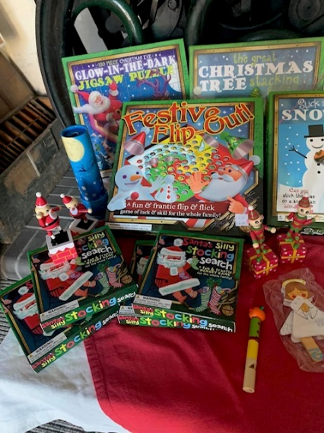

There is STIll chance to purchase air race merchandise.

Stuck for Christmas present stocking fillers pop into the museum and see our range of excellent gifts.

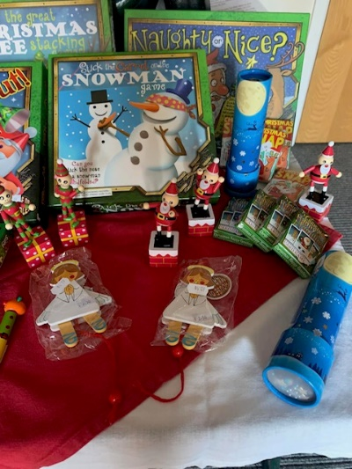

**Mildenhall Museum Society Meetings 2025**

Talks start at 7.30 pm – Members £2 non-members £4

*9th January 2025 Kevin Boardman – Wharram Percy, a year in a Medieval Village.

*PLEASE NOTE THIS MEETING WILL INCLUDE THE AGM START TIME 2.00 PM

6th February 2025 Arthur Rivett – Pembrokeshire wildlife.

6th March 2025 Ed Lowis – History of Secondary Education in Mildenhall.

3rd April 2025 Martyn Taylor – Chequer Square and Angel Hill.

1st May 2025 Imoden Radford – Tales from the Riverbank.

**WHATS IN A NAME?**

What's in a name? A recent newsletter (No.77)  of the Friends of Thetford Forest gave the following explanation of the name Mildenhall.

In a charter of 1050, it was listed as MILDENHALE.  By the time of the Domesday Book (1086) the town was listed as  Mitdenehalla  and possibly meant "middle nook of land" from the Saxon words ' middel' and 'halh',corner or nook or valley. Alternatively. it could be a corner of land belonging to a woman called "Milde" or a man called "Milda".

Museum opening times leading up to Winter Break are

Tuesday, Wednesday, Thursday and Saturday 2:00 – 4:00 pm

and Friday 10:30 am – 4:00 pm

The Museum will close on Saturday 14th December for the winter break and reopen on Saturday 1st March 2025

**The Volunteer Training Days will be**

**Monday 10th February 2025 10:30 am and Tuesday 11th February 2025 2:30 pm**

**The Museum Annual clean – up will take place on Wednesday 26th February 10:30 am many hands make light work.**

Alice Collyer

In the museum storeroom is a cardboard tray marked ‘ongoing projects.’ I discovered, at the bottom, an enquiry asking for information about an orphan, born in London, who had been ‘boarded out’ from Islington Workhouse to The Home for Waifs and Strays at Beck Row in 1906. The gentleman inquirer had left an address in Australia for any information available.

Simpsons Retrospect of 1883 reported that Beck House at Beck Row had been ‘fitted up’ for the reception of orphan girls. This was a branch establishment of the Church of England Central Society for providing homes for waifs and strays.

I used ‘Ancestry’ and ‘Find My Past’ to trace the childhood of Alice Collyer. The family first appeared as inmates in Hackney Workhouse in 1898. Father Samuel, wife Alice, three sons and two daughters, Alice being born on November 4th, 1897.

In total they had ten children of whom four died as infants. The three eldest children, Samuel, Charlotte, and William were sent to Islington Workhouse in 1899 the reason being given as ’deserted’. At these times Scarlet Fever and Typhoid were rife and in 1901 William, Alice and Samuel were sent to the fever hospital at Homerton. Sadly, William died aged five. Alice was discharged and sent to Andover children’s home for a while but then returned to the Workhouse until 1906.

Her brother Samuel and sister Charlotte [Lottie] had already been boarded out at Mildenhall and Alice was sent to join them. Alice found a home with Mrs David Stebbeds, a widow, in Holywell Row and her name was entered into the Admission Register of Beck Row Board School on April 23rd, 1906. Alice was still with Mrs Stebbeds in the 1911 census but her last day of attendance at school was August 2nd, 1911, with a note that she would now attend Mildenhall School. Mrs Stebbeds died in 1912. Alice disappeared from the census returns and Mildenhall. Still intrigued by who had left the message at the museum I wrote to the address in Australia. Four weeks later I received an answer.

Mrs Beverley Jenkins, 85, answered my letter to tell me that herself and her husband had visited the museum in 1988 and left the message. They were looking for information about her husband Ron’s mother, Alice Collyer. Sadly, Ron had passed away eight years ago. Beverley told me that Alice had run away to London and worked, during the early hours, in the basement of an hotel making sandwiches for the Covent Garden market workers. She then moved to work in a private home as a cook. While there she met four other girls and in the 1930’s they emigrated to Australia. Alice arrived in Sydney and lived with friends until she married Percy Jenkins in 1935 and had two sons. Alice died in 1982. Beverley said that Alice was an excellent cook and had led a happy life with grandchildren and great-grandchildren. Alice never knew her correct date of birth and little about her family. Referring to Alice’s stay in Holywell Row Beverly said she always said that an old Granny was very kind to her. We both assume this was Mrs Stebbeds.

Susan Cook.



**Look out for our new Facebook page.**

**Mildenhall and District Museum with the Air Race Logo.**